Math 180 Fall, 2014 Assignment 10
This assignment is due on Tuesday, November 18.

The second Midterm will be distributed on Tuesday, November 18, and will be due on Tuesday, December 2. Some of the questions will be on Bazemore v. Friday, which is discussed in Chapter 9, but may go beyond what is presented there, e.g., What can you say about the progression of cases, Presseisen v. Swarthmore, Bazemore v. Friday, and Wal-Mart Sores, Inc. v. Dukes.

- Here are two pages from Facts from Figures by M. J. Moroney, a small book which is now out-of-print. 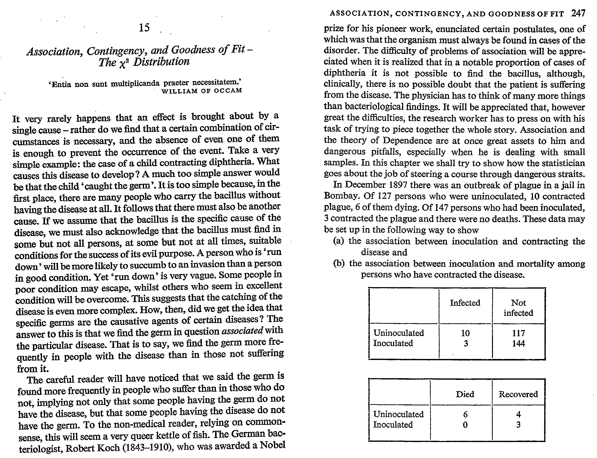
Compute the value chi-square for the first table, both with and without the Yates’ correction, and give the corresponding p values. Should one use a one-tailed or two-tailed test here? Does it matter? Then go online and calculate the value given by Fisher’s exact test. Apply Fishers’ exact test to the second table. Do this by hand and show all your work. (You can check your result online.) Were those who were inoculated but subsequently infected significantly more likely to recover? How would your answer change if the number that died were 7 (instead of 6), all of whom were uninoculated? If it were 8? (You may do these by computer.)

- The following question is taken from Statistics by Freedman, Pisani and Purves.
According to Esquire Magazine,
If you want to play roulette, do it in Atlantic City, where the house lets you “surrender” on the results 0 and 00 – that is, returns half your wager.
The roulette wheel has 38 pockets, numbered 0, 00, and 1 through 36 … 0 and 00 are green. Of the other numbers, half are red and half are black. If you bet $1 on red and a red number comes up, you win $1. If a black number comes up you lose $1. But if 0 or 00 comes up, you lose $.50 – because of “surrender.”
A gambler in Atlantic City plays roulette 100 times, staking $1 on red each time. Find the chances that he comes out ahead of the game.

