Math 180 Fall, 2014 Take-home Midterm 1

This midterm is due Tuesday, September 30. Each problem is worth 50 points, even though they are of varying difficulty. Scores (range 2 – 5): 100 = 2, 150 =3, 200 = 4, 250 =5. The exam is long, so it will be helpful if you work in teams, but you may work with anyone in the class. Answers to questions must be on different sheets of paper, in order, and stapled together with the printed cover sheet, which will be emailed to you. You may consult texts and the web; if you find and use any relevant material be very careful to cite your sources.

A. You are a government attorney who is being consulted by the state’s licensing bureau.
The bureau processes applications and collects fees in connection with a wide range of licensed activity, from hunting to trucking to haircutting. There has been a longstanding problem with one sector in particular: car services (companies, often consisting of a single individual, who offer personal transportation). The annual license fee is $1000, but many individuals who operate car services simply do not register or pay the fee. There are three-fold damages when these individuals are caught (that is, they must pay a total of $3000), but in a given year they face only a 10% chance of capture. If they are captured, however, they usually pay twice this amount, $6000, because it can usually be demonstrated that they cheated on their prior year’s fee as well. (The statute of limitations precludes levying fines for earlier years.) It has been proposed that the license bureau follow the lead of many state tax collection agencies and offer an amnesty program. The proposal is that any individual who admits to operating without a license can pay the regular fee of $1000 and be excused both from the penalty (the additional $2000) and be immune from prosecution for the prior year’s fee and penalty. There would be a modest cost in setting up the program, mainly involving publicizing it widely.

Advise the licensing bureau regarding this proposal. In preparing your advice, be sure
that you do each of the following:

1. Write down the licensing bureau’s game tree for the decision whether to offer the
amnesty.
2. Solve it. Be sure briefly to explain your work in some fashion that will communicate to
the licensing bureau how you reached your conclusion.
3. Briefly (one or two paragraphs) offer additional comments you think appropriate in
advising the licensing bureau on its proposed amnesty program.

B. Here is the pay-off table for a two-person, zero-sum game. The players are Amy and Bill; Amy has two strategies, S1 and S2, while Bill has five, T1, T2, T3, T4, and T5.
Bill
1 | 23 | 2 | 12 | 10
18 | 2 | 12 | 4 | 14

Amy

Solve the game, i.e., find the probabilities with which each player should play each strategy and give the value of the game to Amy. (The graph below, which is an aid to the solution of this game, was originally sent out on September 14.)

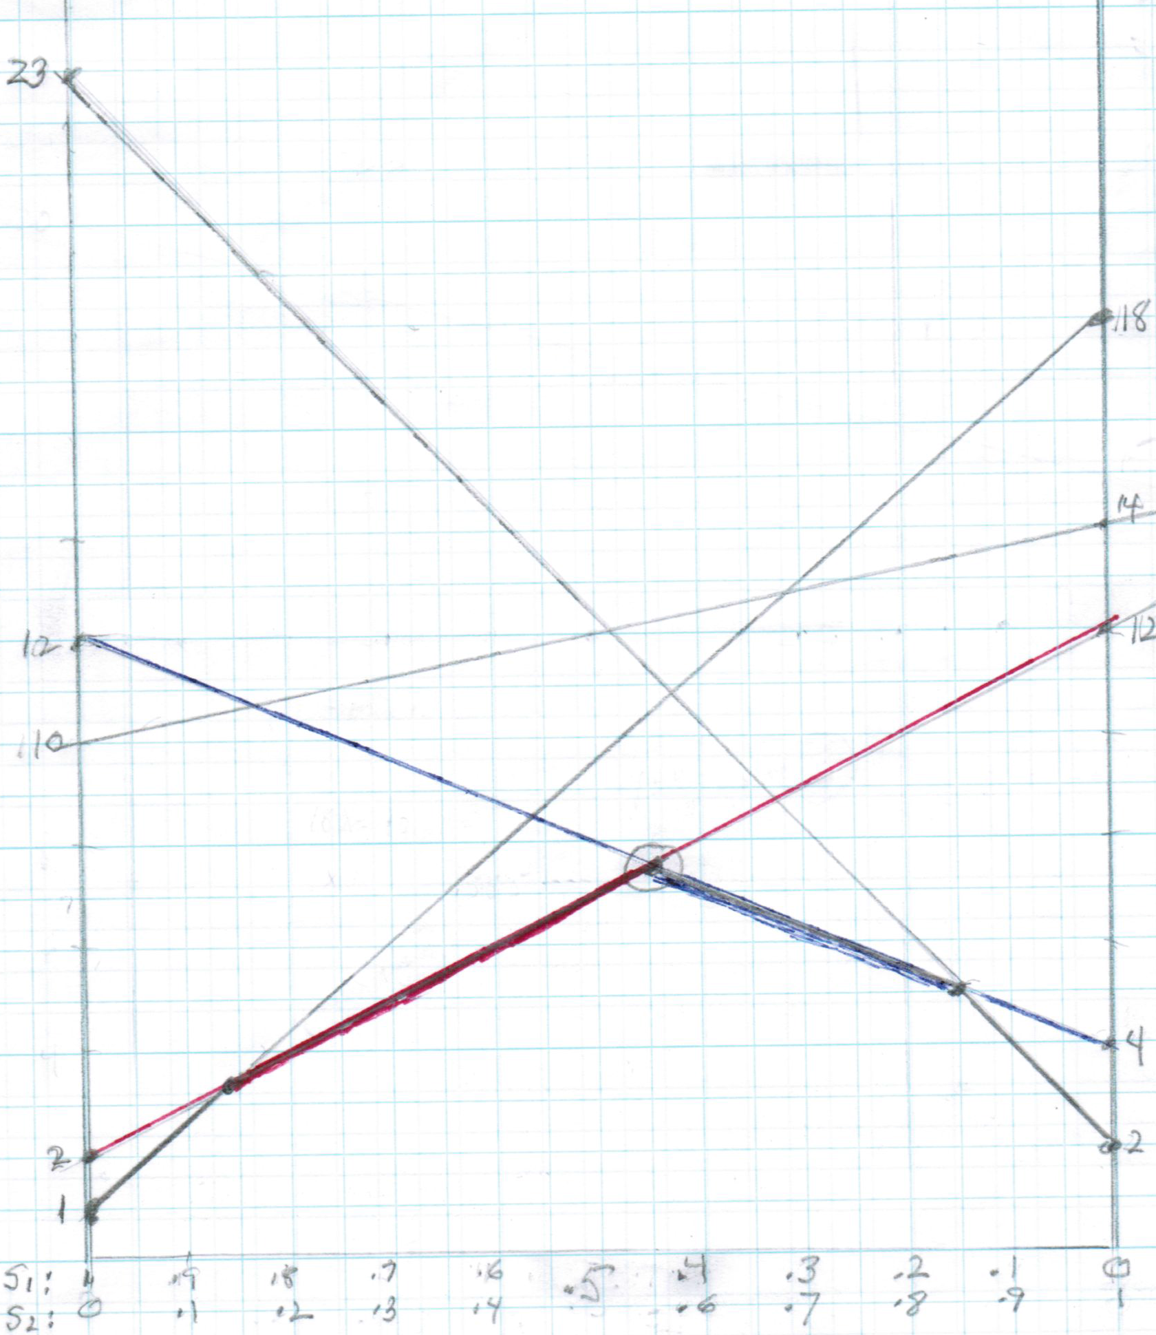

C. Suppose that you have been fortunate enough to win the Powerball lottery and are entitled to $50 million "annuitized": you have a choice of an immediate payment of $25 million or $2 million a year for the next 25 years. Assume an interest rate of 5% per year. Which should you choose? Explain, giving, in particular, the present value of the annuity.

D. Each of three players, Able, Baker, and Charley has three strategies: Able has strategies A,B, and C, Baker has strategies P, Q, and R, and Charley has strategies X, Y, and Z. Each can choose one, so there is a total of 3×3×3 =27 possible choices. It would be easiest to represent this as a cube, but that is impossible here, so the payoff matrix is given below in tabular form. The first three rows are really three 3×3 blocks showing the payoffs if Charley chooses strategy X; the next three rows are similarly three 3×3 blocks showing the results if he chooses Y and the last three if he chooses Z. Inside each block, a row of three numbers gives the respective payoffs to the three players.
For example, if Able chooses A, Baker chooses P and Charley chooses X, then the payoffs to Able, Baker, and Charley are 2,2,2, respectively. If Able chooses C, Baker chooses Q and Charley chooses Z then the payoffs are 1,2,1. Find all Nash equilibria amongst the pure strategies. (The numbers were generated by a random number generator.)

P Q R

2 2 2  3 3 2  4 3 0 | 3 3 3  3 0 4  0 4 0 | 4 2 0  4 1 0  4 4 4
4 1 1  2 2 2  2 2 4 | 0 3 1  4 2 1  3 3 0 | 1 4 2  0 3 4  4 1 3
2 3 0  0 3 1  2 2 2 | 2 4 2  0 2 4  1 2 1 | 3 1 2  2 4 1  3 0 1
A
Here is the B
Payoff matrix C
For a game with A
Three players B
Able C
Baker and A
Charley. B
. C

Extra credit (hand in on a later date): Are there any Nash equilibria amongst the mixed strategies? These, if they exist, are harder to find.

Braess’ paradox, credited to the German mathematician Dietrich Braess, states that adding extra capacity to a network when the moving entities selfishly choose their route, can in some cases reduce overall performance." (Wikipedia)

It is a relatively recently discovered phenomenon which has actually been observed in practice. It would make a good topic for a presentation. Do the exercise on Braess' paradox on the following page.

E. Here is an application of the concept of Nash equilibrium in determining the expected
flow of traffic in a network. Consider the network of roads below in which cars must travel from A to D. (Notice that the roads are all one-way.) Assume that 100 cars must make the trip and that the travel times from A to C and from B to D are each 2 hours and that from B to C is .25 hour, independent of the number of cars that travel these roads. However, the travel time from A to B depends on the number of cars that choose that road: if the number of cars is x then the time it takes is 1 +x/100 hours, and likewise for the link CD. (The “x” on the AB link is not necessarily the same as on the CD link. For each link it is just the number of cars traveling on that road.) The problem is to find the expected distribution of traffic in the network.

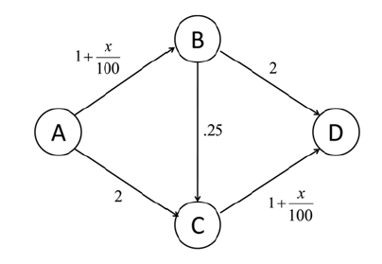
We may view this as a game in which the travelers are the players and each has a choice of 3 strategies, namely, the paths ABD, ACD, and ABCD. The “payoff” (actually penalty) for each strategy is the travel time of the chosen route. The payoffs for any given strategy depend on the choices of the other players, as is usual. The goal in this case is to minimize travel time. Equilibrium will occur when no single driver has any incentive to switch routes, since it can only add to his/her travel time. If, for example, 100 cars are traveling from A to D, then equilibrium will occur when 25 drivers travel via ABD , 50 via ABCD , and 25 via ACD . Every driver now has a total travel time of 3.75. This distribution is not socially optimal. If the 100 drivers agreed that 50 travel via ABD and the other 50 through ACD , then travel time for any single car would actually be only 3.5 hours. This is an example of
Braess’ paradox: Sometimes closing a road actually decreases travel time. In this picture, if the number of travelers is small (suppose, for example, there were only one) then the link BC is useful (for he could then choose ABCD and make the trip in2.27 hours, far less than ABD or ACD).

1. Is the distribution where 50 drivers choose ABD and 50 chose ACD an equilibrium? 2.
Show that the distribution above (25 drivers traveling via ABD, 50 via ABCD, and 25 via
ACD) actually is an equilibrium. Is there any other? 3. Show that if the number of
travelers is large enough then at equilibrium no one will use the link BC. 4. There is a
range in which, because of the link BC, the equilibrium is not socially optimal and it
would be better to close it. What is that range? (For example, with 100 travelers it is
better to close BC.)

3, 4 | 5, 7 | 9, 2
2, 10 | 8, 8 | 12, 4
F. Amy and Bill have been litigating over an heirloom teapot. As discussed in class, if they go to trial they have possible strategies and payoff matrix given by the following table.

Expert Witness Consultant Do Nothing
Discovery
No Discovery

Amy suggests to Bill that they sign a contract under which Amy will choose No Discovery and Bill will choose Consultant, so that the total payoff to them jointly will be 16. Bill, seeing that he has the advantage, demands that Amy pay him part of the 8 he will receive. Compute the Nash equilibrium and decide how much you think that Amy should offer to pay Bill in order for the outcome to be fair. Give your reasons. (If Amy offers too little, Bill will walk away; if she offers too much she disadvantages herself. Assume that both are wiling to be reasonable.)

