Supplement A

Measurement with whole numbers

A1: Weight and height in nonstandard units

The counting concept is the basis for the processes we call measurement. Let's look first at the idea of weight. According to Webster's New Collegiate Dictionary, "weight" is "the force with which a body is attracted toward the earth or a celestial body by gravitation". If we think of it this way, it is quite easy to see how we could check if two children were of the same weight--take them to a balanced seesaw on the playground, have each mount a side, and check to see if the seesaw remains balanced. If so, they are of the same weight, if not the heavier child will be on the side that ends up on the ground. In a sense, the seesaw here plays the role of the balance scale, used to compare the weights of two objects.

There are several situations in which we might like to have more information than simple balancing can give. One occurs when we want to compare the weights of two children who are never in the same place, so they can never get on the same seesaw. A second occurs when we want not only to know which child weighs more, but how much more the child weighs. If we know how to count, we can handle both of these situations in the following manner. We take one child and a large number of identical heavy textbooks to the seesaw, seat the child on one side, and begin piling books on the other seat until the book pile balances the child. We count, say, 23 books and say that the child has the weight of 23 books. We repeat the procedure with the second child at a different time and/or place (but with books of the same weight as those used originally) and find that the child has a weight of 21 books. It is now easy to conclude from the number fact
21 < 23 that the second child weighs less that the first, and the difference is two books. If you have ever seen a balance scale used in a market, you will recognize this process--the salesperson puts the produce on one side of the balance, and ounce weights on the other until the two sides balance. When they balance, the cost is determined by the number of weights used.

We might describe our weighing process as follows:

i) Select a unit of weight (a textbook perhaps)
ii) Balance the object to be weighed with a number of unit weights
iii) Count the units used

It is easy to visualize a large number of classroom activities that could be carried out to illustrate the weighing process, using only a simple balance scale. How many paper clips does a pencil weigh? How many pencils does a notebook weigh? How many marbles does a glass of water weigh. Of course, if we hear that a glass of water weighs 20 marbles, that doesn't really give much information about the glass of water unless we know how big the marbles are. It is to reduce this sort of uncertainty that certain standard units of weight, such as ounces, pounds, grams and kilograms have been agreed upon for common usage. Wherever we travel, a gram means the same thing it did at home. In fact, we could carry a bunch of one gram weights around with us if we wished. When someone said a glass of water weighed 100 grams we would know exactly how heavy it was. Once a standard unit of weight has been agreed upon it is a simple matter, with the use of available technology, to replace the slow and tedious balance scale with an instrument that provides an immediate numerical display of the number of units which would be necessary to balance any object set upon it.

A point to ponder: If we weighed a glass of water on a balance scale by balancing it with a set of gram weights, we still wouldn't really know exactly how much the water weighed. Why not? How could we correct the measuring process to get the exact weight of the water?

Let's think about another attribute of children we might want to compare--height. If we have two children together, it is again a simple matter to compare their heights. We stand them on a level surface, back-to-back, and look to see which head rises above the other. If neither does, the two are of the same height, otherwise we would say that the one rising above is the taller (has greater height). As with weight we have difficulties with this process in comparing separated children and in describing how much taller one child is. Again our textbooks, if thick enough and numerous enough, can be used to advantage. We simply stack books beside the child until the top of the top book is level with the top of the child's head. If 25 books are used, the child is 25 books tall. Repeating this with the second child, and books of the same thickness, we can compare the heights by comparing the numbers!

Notice the similarity of our process for measuring height:

i) Select a unit of height measure
ii) "Balance" the height of the object to be measured with a number of units
iii) Count the units

If our classroom has concrete block walls, we could measure each child's height in "concrete block" units by asking each to stand against the wall and counting blocks until we came to the top of the child's head. In this case, we would probably observe a drawback to our measuring technique. In all likelihood, the top of the child's head would not align exactly with the top of a block, so the number of blocks we count would only give an estimate of a child's height, rather than the exact height (of course, a similar problem might also have in our weighing process). In this case, we might find two children who we would say are 25 books tall, yet who were not exactly the same height when standing back to back. This sort of inaccuracy in measurement is one of the motivating factors for introducing new number systems--fractions, irrational numbers.

As with weight, it is easy to see that information about height can be most accurately and effectively be communicated with the help of a system of standard units of height measure--feet, yards, meters, etc. Again, as in the case of weighing, once we agree upon a common unit, we can simplify the measurement process by constructing measuring instruments--rulers or tape measures for instance--which can make the measuring process much easier that stacking books or other objects and counting.

A2: Measuring segments

Much of the vocabulary of geometry was originally introduced to facilitate discussions of measurement. This is not surprising, since the origin of the word geometry is in the Greek for "measurement of the earth". To see how geometric concepts arise, think about the discussion of height measurement in A1. In comparing the height of two children, we ignore most attributes of the children, for instance it matters not at all whether one is fat, the other thin. All that matters is that they stand upright on level ground, and that we know where the highest point on their head is. We could as well have each child stand against a narrow tape pasted vertically on the wall, and mark the tape at a level even with the top of the child's head. The higher the mark, the taller the child. The tape stretching from the floor to the top of the child's head provides a representation of all information that is essential to measurement of height. Personality doesn't count, age doesn't count. Only the marks on the tape. The tape in this illustration, made as thin as we wish, becomes the “ideal” object representing length and is called a line segment (it is thought of as having length but no width), or just a segment. Informally, we think of a segment as a straight path in space which joins two points, called its endpoints.

From a point of view of height, the line segments pictured in Figure A2-1 might represent three children whose heights are to be
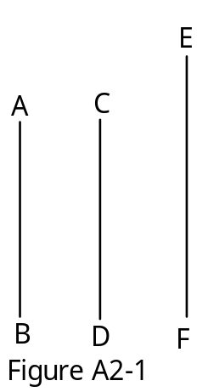
compared. Rather than Sue, John, and Mary, these representations could be called 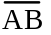, 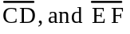, with the pair of letters naming the endpoints of the segment. If the segment were placed on 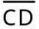, it would fit precisely, so these segments represent children of the same height, a similar comparison of segments shows that 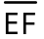 represents a taller child.
The idea that one segment can be placed to fit exactly on top of the other so as to make the endpoints coincide, is called congruence. In Figure A2-1, one would say that 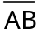 is congruent to, but is not congruent to . A compact notation for the statement " is congruent to 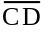" is  ≅ 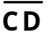. In simpler language, a child would probably say that is the same length as , rather than using the more formal terminology “congruent”. Notice that the idea of same length can be understood before the idea of a numerical length is introduced.

Of course, since segments are used to model height, and heights can be given numerical values as in A1, there should be a numerical measurement called the length of or the distance from A to B for each segment. The process which assigns such a number to a segment , usually called linear measurement, mimics exactly the measuring processes we've already encountered.

a) Select a unit segment
b) Cover the segment with segments congruent to the unit segment laid end to end, and with no overlap
c) Count the segments

As an example, look at the segments in Figure A2-2.
If we take to be our unit segment, we see that are segments congruent to which exactly cover . Counting these segments we find that the length of is three units. It is customary in many texts to use have a "shorthand notation" for the length of a segment , namely XY (the bar above the segment name is simply omitted). The linear measuring process can be carried out in the schoolroom or the schoolyard, using a variety of nonstandard units. For instance, one might determine the length of the classroom in floor tiles (the tiles are the unit “segment”) ,the length of the sidewalk in concrete squares or the width of the playground in student shoes. (Do you see a possible problem here if many different students helped measure?)
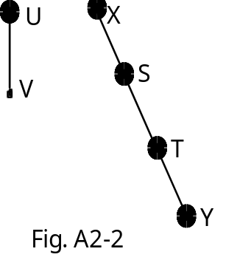

A child with enough measuring experiences would likely discover that, for a fixed unit, any two congruent segments have the same measure. This is a fundamental property relating congruence and measure. We will call it the

Congruence property:
If the segments and  are congruent then AB=XY

For our example A2-2, we made a very careful selection of our segment and of the unit, to assure that a whole number of unit segments could cover the segment 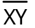 exactly, without overlap. This makes the segment have a precise whole number length. In actual measurement situations, the unit segment and the segment to be measured are often both specified in advance and we must do the best we can with this measuring process and the whole numbers. The result will often be that lengths can only be specified approximately, to the nearest unit.

In practice one seldom, if ever, measures by actually covering one segment with unit segments and counting. One constructs or acquires a measuring device (a ruler). This is a physical model of a segment--a stick or some other easily portable straight, narrow object--on which are marked endpoints of a sequence of unit length segments, laid end to end, beginning at one end of the object. In order, we label these marks 0,1,2,... as we move by unit steps from the beginning. To measure a segment , we simply lay the
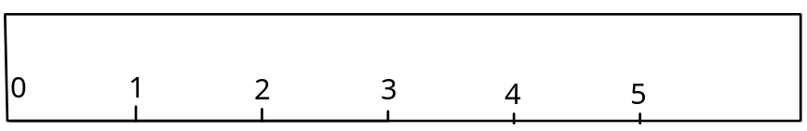
ruler along the segment with the point labeled 0 lined up with the endpoint X. The number on the ruler that lines up with the endpoint Y must give the length of the segment. If we wish to use standard units, centimeters or inches for example, we of course do not need to build out own ruler. Commercially prepared versions of rulers and measuring tapes in these units are readily available.

A ruler not only provides a tool for measuring, it also provides a useful visual model of the set of whole numbers which displays them in their natural order. If the ruler is positioned horizontally, with the point labeled 0 at the left, inequality of whole numbers is given a concrete meaning--a number m is larger than a number n if m labels a point lying to the right of the point labeled n. When a ruler is used in this manner to demonstrate the order properties of the whole numbers, it is often referred to as a number line.

Exercises

1. i) Taking the segment as a unit, make a paper ruler of length 8 units and measure the segments a), b), c) and d) (indicate whether these measurements are exact or are to the nearest unit)
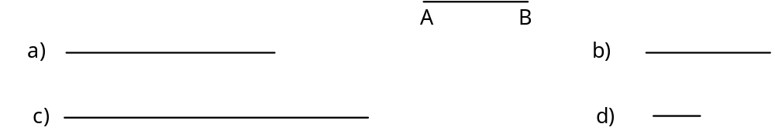

ii) Without making a ruler, one could use a compass to mark off segments congruent to on each of the given segments. Do this and count segments to check the answer you got in i).

2. On a number line, what is the length of the segment between the points labeled 17 and 21? Sketch this part of the number line and count.

3. Johnny's ruler broke so that both the 0 and the 1 were lost. He threw it away, saying that it wouldn't work anymore. Was he right? Explain.

4. Are either of the following statements true? Explain your response.

a) If 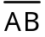 ≅ then AB=XY.
b) If AB=XY then ≅ .

5. Determine which of the following pairs of segments are congruent without measuring. Explain your method.
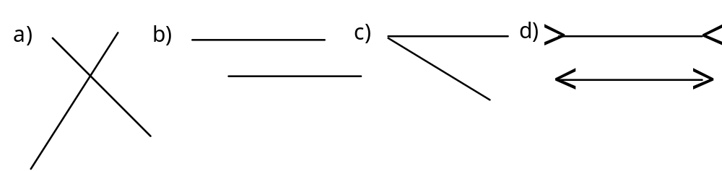

A3. Measurement of area

Covering and counting, the procedure that allows us give a numerical value to the length of a segment, also describes a different type of measurement problem, that of describing the size of a flat region--a plot of land, the floor of a room, a wall, the surface of a lake. In geometric terminology each of these regions is a model of a portion of a plane. They are only portions, as a plane is considered to extend indefinitely, and these regions are enclosed. The outer edges of the regions we consider are examples of plane curves (curves in a plane). We can best think of a curve as a figure in a plane that could be drawn with a pencil without ever lifting the point from the paper and without ever retracing any part of the figure. Circles, squares, rectangles, and triangles are examples of curves that are familiar to children. Beginning as one might in an elementary classroomwe will not try, at this stage of our discussion, to describe these curves by their attributes, since there is some evidence that young children do not classify shapes by attributes but rather understand them as a whole. We will, for now, think of squares, triangles, etc. by simply picturing their shapes. How should we attach a number (called the area) to the size of a region? Let's try to mimic our approach to lengths. We should

i) Select a unit
ii) Cover the region with units without overlap
iii) Count the units

If we attempt to carry this process out, we are confronted by an initial decision that did not arise in length measurement. We have a large number of possible choices for the shape of the unit of area. For instance, to measure the area of the quadrilateral ABCD below, we might choose as our unit
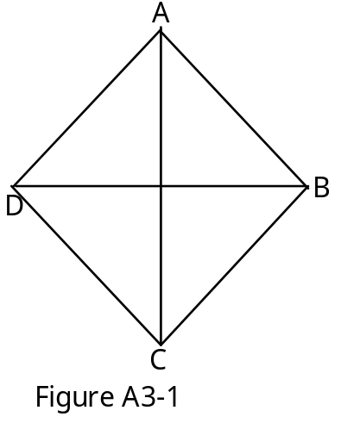
of area one of the four triangles in the ABCD. If we trace any one of the triangles, lay the tracing on top of another, and compare, we will find that it fits exactly. We say that all four triangles are congruent to the unit triangle. So the area of the quadrilateral ABCD is 4 units.
On the other hand, if we were to look at the area of the rectangle in Figure A3-2, we could choose the small triangle as unit, giving an area of 16 units; or we could choose the small rectangle as unit , giving an area of 8 units.
The conventional choice for a unit of area is a square with sides of length one unit (in whatever length measurement system we decide to work). So if we are working in inches (for instance we might be interested in the size of a book cover), the unit of area will be a square one inch on a side (a square inch). If we want to measure a room for carpeting, we would probably use a square of side length one yard (a square yard), while for a measurement in a scientific laboratory experiment we might use a square of side length one centimeter (a square centimeter).

The problem of covering a given region precisely with units is even more difficult than it is for segments. For example, Figure A3-3 represents a small lake covered by 35 unit squares. So we know the area is less than or equal to 35 units. On the other hand, if we look at the unit squares which are completely contained within the lake, we see that there are only 16. So the
most accurate statement we can make about the area A of the lake is that 16≤A≤35 units. A smaller unit would make the approximation better, but as long as we are restricted to counting only complete squares, we will have difficulty getting a really good approximation.

Just as with length, it is clear that two regions which are congruent (in the sense that one would fit precisely on top of the other) can be covered with exactly the same number of unit squares. This is the

Congruence property for area:
Two congruent regions have the same area.

There is an interesting difference between length measure and area measure related to the congruence property. If, for some unit of length, and both have length 3 units, then ≅ . This can easily be demonstrated by building a model of and one of from unit segments and comparing them. However if R1 and R2 are rectangular regions, both with area 12 square units, it need not be true that R1 and R2 are congruent. Try to draw two such rectangles which are not congruent! Of course, there must also be circular regions of area 12 which are not congruent to any rectangular region. In fact, we can easily imagine that there are infinitely many different shaped regions, all of area 12.
Related to this strange behavior of area is another important property of
area measure, sometimes called the dissection property of area. This property says that if we take one region, cut it up and reassemble the pieces into another region (without overlapping pieces), the new region and the original will have the same area. For instance, the triangle DABC in Figure A3-4 can be cut apart to remove the small striped triangle, and reassembled to give the rectangle EBCD, so DABC and rectangle EBCD have the same area. If the small square is the unit, this shows that DABC has area 2 units. Tangrams can be used in the classroom to provide hands-on illustrations of this property (see Lab 27)

Exercises:

1. Draw a rectangle which is 3 cm wide and 5 cm long. Show how this rectangle can be covered exactly by unit squares one cm on each side. Count the units to find the area.

2. If the small square drawn here is the unit, what is the area of the triangle drawn. Explain your reasoning.

3. Sketch three non congruent regions all with area 6.

4. A segment can be thought of as a region in a plane which has zero width. What should the area of a segment be, measured in square inches. Explain your reasoning. (Do not resort to some known formula for area!)

A4. Measurement of volume

Let's just discuss briefly here how the ideas of measurement of length and area can be copied to attach a numerical value to the volume of a three-dimensional object such as a box (a rectangular solid to be precise), a cylinder, a ball (sphere), or even some irregularly shaped object such as a rock. To copy the measuring processes we've used before, we should first choose a unit of volume, then "cover" the object we are measuring by units, and finally count the units. A natural choice for a unit would be three dimensional analog of the segment (one dimensional) and the square (two dimensional), the cube which is one unit long on each side. We'll call that the unit cube and speak of volume measured in cubic units--one cubic inch, three cubic centimeters, and so on is we are using standard units.

One big problem we immediately come across in trying to measure volume is that of "covering" a solid object with unit cubes. As a first example, we could think about a rectangular solid in the form of a box (closed of course). To handle this, we could open the box, and place as many unit cubes as possible inside the box. If we count the cubes, we should have an approximation of the volume of the box. Of course, it is unlikely that the cubes will fill the box exactly. There will almost certainly be some space left over, but it will be shaped wrong for another cube to fit in. In this case we have a lower estimate for the volume of the box. If our unit of length was taken smaller, our unit cubes would also be smaller, so we should be able to leave less empty space, thus getting a more accurate measurement.What might we do if the box couldn't be opened, or if our object of interest was of a shape that couldn't be filled easily with cubes? One clever approach has to do with displacement, the idea that if we were to take a solid object (a baseball for instance) and submerge it in a pan of water which is filled to the top, the volume water which spills over should be the same as the volume of the ball (since the ball has filled in the space the water previously filled). Now if we could capture the water in a rectangular pan, we would have essentially reshaped the volume of the ball into a box, and we know how to estimate the volume of a box. In practice, one can easily acquire graduated cylinders which display the numerical volume (in standard units of cubic inches or cubic centimeters) of any amount of water that is poured into the cylinder. So the volume of the baseball could be determined by pouring the displaced water into a graduated cylinder. A rough version of a graduated cylinder displaying any desired (small) nonstandard cubic unit can be made from a cylindrical drinking glass, with suitable 1 cubic unit gradations marked with a magic marker.

The procedure of measurement by displacement works well with irregularly shaped objects like rocks, as well as more regular shapes. A sponge could give some problems! How could you overcome them without destroying the sponge? The idea that the box of displaced water has the same volume as the object that displaced it is an extreme illustration of the dissection property of volume, which says that if a three dimensional object is cut up and the pieces recombined to form another object, the new and old objects will have the same volume.

One of the strong points of the metric system of measurement is that there is a relationship not only between units of length, area, and volume, but also of weight. In particular, a cubic centimeter of water weights exactly one gram! In a classroom provided with a good balance scale and graduated cylinders, students could experiment and discover this for themselves.

Exercises:

1. Use unit cubes to build a rectangular solid which is 3 units tall, 3 units wide and 4 units long. Count the cubes. What is the volume of a 3 by 3 by 4 box? Can exactly the same cubes be used to build another rectangular solid? If so, what can you say about the volumes of the two solids? What property of volume is at work here?

2. A square plane region can be considered an object in three dimensional space, so it should have a volume. What should it be? Explain.

3. A very small rectangular container with vertical walls which is 5 cm long and 2 cm wide is filled to a depth of 2 cm with water. What is the weight of the water?

A5. Angles and their measure

The concept of angle seems a bit more subtle and remote than that of segment or plane region. To be sure, there are many angles to be found in the everyday world of a child, but they are always part of something else (a block, a star, a room, a roof, etc.) For a child is at a stage of development in which all objects are seen holistically, and not as the sum of their parts, the concept of an angle as an independent geometric object might well be missed. How would we describe an angle once we began to see objects as the composite of their parts? Let’s consider a puzzle piece in the shape of a triangle, Fig. A5-1. A child trying to fit this piece into a square hole on the
puzzle board might well observe that it fails to fit because the sides of the triangle are longer than the sides of the square. But even if the sides were the same length, the triangle would still fail to fit perfectly because the “corners” of the triangle are a different size than the corners of the square. The corner, of course, is a representation of an angle.

How do we describe this angle concept? This puzzle piece representation suggests that an angle is just a figure consisting of two segments which have a common endpoint, the vertex of the angle. This must be the picture of an angle that a child has, but it suffers from a minor drawback which is illustrated in Fig. A5-2. There are, by our definition, several angles with vertex at point A; one formed of segments and, one formed of segments and , etc. (How many different angles, by this intuitive
definition, are there in the Fig. A5-2 which have vertex A?) This fact might be insignificant to a child, but the understanding of angles necessary for meaningful applications is that there is really just one angle here with vertex A. How can we resolve this conflict? The mathematically accepted solution is to define:

an angle is a geometric object formed by two rays (the sides of the angle) with a common endpoint
(the vertex of the angle)
where by a ray we understand informally the indefinite extension of from A to B and beyond. With this understanding, we see that = , and =. Now whether we say that the angle at A in Fig. A5-2 consists of rays and , or of and , we have described exactly the same object. The price we pay for this precision is that the angles occurring in nature must have their sides extended to form an angle as defined geometrically.

We again come up against this difference between definition and perception when we try to describe a triangle in terms of component parts--three sides (which are segments) and three angles (which are not really part of the triangle as a geometric figure). Rather than always saying “the angle formed by the rays and we often substitute the shorter symbol BAC. We apply to angles the same intuitive description of congruence we have used for other geometric figures: two angles are congruent if a tracing of one would fit precisely on top of the other.

As we look around our classroom for examples of angles, we are struck by the fact that one particular type of angle predominates. The corner of the room, the corner between ceiling and wall, the corner of the desk, the corners of our books. Such angles are so common as to deserve a name of their own. For small children, that name might be square corners. For us, as we begin to teach and learn correct geometric terminology, the name is right angle.

Let’s think a bit about what it takes to define a right angle, that is, to give an unambiguous description of what is and what is not a right angle. The easiest way, and the way we presumably learned the right angle concept, is to provide a picture of a right angle and say, an angle is a right angle if and only if it is congruent to this angle. But suppose we want to do without a picture? Most people would probably agree that a right angle is an angle with a measure of 90 degrees. This is true, but it is only helpful in describing a right angle to someone who has never seen one, if that person knows exactly what one degree looks like and is willing to draw 90 angles of this size. Another possibility would be to say that it is the angle formed by perpendicular rays. But what shall we say “perpendicular” means? Usually we define perpendicular rays to be rays with the same endpoint which form a right angle. We cannot use both of these definitions at the same time without creating circular reasoning, in which case neither is useful. Challenge: define a right angle without using angle measure or the word perpendicular.

Just as with segments or regions, it would be convenient to be able to assign to each angle a whole number measure, which would somehow describe how big the angle is. Since we have developed in other situations a measuring process that was useful, we might begin our investigation of angle measure by trying to mimic what has been done before, and seeing what if anything needs to be changed. The process we propose is:

a) Select a unit angle
b) Cover the angle to be measured with angles congruent to the unit angle, laid side to side with the same vertex and with no overlap
c) Count the angles

Fig. A5-3 demonstrates how this process would show that the measure of XYZ is approximately (but slightly less than) four units if we take ABC as the unit angle. This process does indeed describe a usable method of assigning numbers to angles (Try to determine the measure of a right
angle in this system if ABC is the unit). We denote the measure of XYZ by the symbol m(XYZ). It is worth thinking about the fact that for many students, young or old, the frequent use of symbols in place of the full name of a concept can lead to confusion and frustration. It is often wise to keep the use, and even introduction of, symbols to a minimum until it is clear that the students have a firm grasp of the
concept at hand. The worst case scenario is that in which a student mistakes memorization of symbols for the learning of concepts.

There are some subtle problems with our description of the measuring process for angles. These deal step b). Remember that an angle consists only of two rays. Then notice that in Fig. A5-3 it is not actually true that we have "covered" the angle XYZ with copies of the unit angle, since no ray of a unit angle falls exactly on . In fact, this could happen only if the measure of the angle was exactly four units. What we really need here is to be able to talk about covering the interior of XYZ with copies of ABC and its interior, where by interior of an angle, we mean intuitively the region of the plane lying between the sides on the angle. The interior of an angle is shaded in Fig. A5-4.
Observe that the angle PQR actually divides the plane into three distinct parts, the exterior of the angle, the interior of the angle, and the angle itself, which is neither in its interior nor its exterior. There are actually two different ways we could try to measure PQR beginning at and using a given unit angle. We would start at and lay off unit angles until we reached , moving either through the interior or through the exterior. Certainly this would result in two different measurements for the same angle, an ambiguous situation we would prefer to avoid at the time angle measure is first introduced. To clear up this ambiguity, we should replace step b) of the measurement process by:

b') Cover the interior of the angle to be measured with angles congruent to the unit angle and their interiors, laid side to side (with the same vertex), and with no overlap

At a later date in the educational process, of course, one needs to be able to measure through the exterior of the angle as well as the interior. This will be accomplished without ambiguity by assigning to that measurement a negative value (once negative numbers have been introduced.)

It should be clear that with this angle measurement process, once the unit angle is selected, congruent angles have the same measure. Of course, as with segments or regions, selection of a different unit can make a substantial change in the numerical measure of an angle. There are two standard angle measurement systems which are in use, degree measure and radian measure. In the elementary grades, the degree system is by far the most common, but in science and engineering applications radian measure dominates. In either case, the process is as we have described above, the difference between the systems is only in the selection of the unit. In degree measure, a one degree angle is defined by the property that 360 angles congruent it, laid side by side with a common vertex and with no overlap, would exactly cover the entire plane. In other words, after 360 one degree steps around a point A, we would end right back where we started. It is believed that this selection of a unit angle dates to the Babylonians, who visualized the sun moving around the earth at a rate of one degree per day. So if one year were 360 days, at the end of one year the sun would be back where it started one year earlier.

The radian measure system is in many ways a more logical system than degree measure, since it is tied to the system of segment measure we have already studied. To find the measure of an angle ABC in radians, we choose a unit segment, then take a circle of radius one unit with center B (See Fig. A5-5.) We now measure the distance from 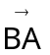 to 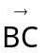 along the arc of the circle lying in theinterior of the angle (as if the arc were a segment). The resulting length is the radian measure of the angle. While this method
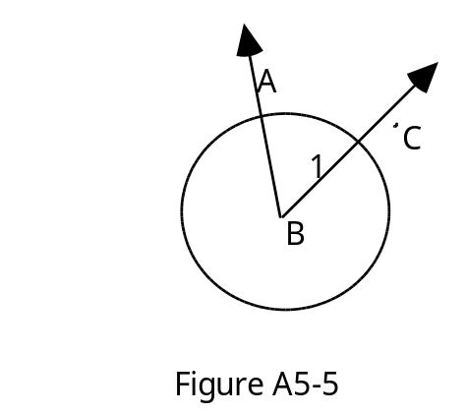
has the advantage of making use of something we already know, namely segment measure, it has some serious drawbacks also. One is that it is difficult, if not impossible, to accurately measure the length of an arc of a circle with a ruler. A second is that commonly occurring angles, such as right angles, not only do not have exact whole number measures as they do in degree measure, they have in fact irrational number measures (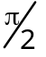 for a right angle). Not a good situation, particularly with young children who have no idea what an irrational number might be, but who are comfortable with whole numbers. A third difficulty, if we were trying to introduce measure to young children, is that the idea of radian measure depends on an understanding of center and radius of a circle, not likely if the child sees the circle holistically.

One strange aspect of angle measure must be emphasized. As opposed to segment or area measure, measures of angles cannot be arbitrarily large. If we think about measuring segments, we know that if we start with a segment 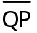 of any given length, we could always lay off one additional unit segment along the ray 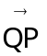 and get a segment one unit longer than . If we continued doing this, we would end up segments one million units long, or more. There are segments which are as long as we wish to have them. What happens if we try the same thing with angles. Let’s use degree measure, beginning with the right angle XYZ in Figure A5-6.
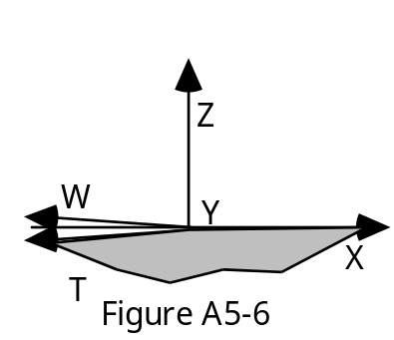
If we now lay off one degree angles starting at 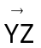 and moving toward 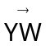 we will get larger and larger angles, just as we did with segments, until we have “added” 89 unit angles, at which time we will have an angle of measure 179 degrees. One more unit angle will get us to 180 degrees, which we see is formed of the ray and its opposite ray. This angle is called a straight angle. What happens next? When we add one more unit angle, we get XYT, which has its interior shaded in the diagram. Since we have agreed to measure angles through the interior, we see that this angle has measure 179 degrees again. Reasoning in this way, we see that there cannot be any angle with measure greater than 180 degrees (or p radians in the radian measurement system). Probably you have studied enough mathematics to know that, as one moves more deeply into the subject, one must change one’s view of angles so that in fact angles too can have arbitrarily large measures. From the standpoint of the elementary school curriculum, however, 180 degrees is the most that is possible.

Just as a ruler makes the process of measuring lengths of segments easier than the process of laying off unit segments, the measuring device called a protractor is used to make measurement of angles easier. A protractor is a semicircular piece of material, usually metal or plastic, on which consecutive 1 degree angles are marked and labeled: 0,1,2,3,...,179,180 (though in reality, only every tenth angle is usually labeled), with 0 labeling the straight edge of the protractor. To measure an angle, one need only lay the protractor on the angle being measured, the center falling on the vertex, the edge labeled 0 precisely on one side of the angle and the protractor positioned so that the other side of the angle is covered by the protractor. The number on the protractor angle which falls on this other side is the measure of the angle in question.

Exercises:

1.
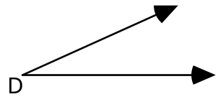
If D is the unit angle, what is the largest whole number which could arise as the measure of an angle?

2. If 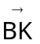 bisects (divides into two congruent pieces) ABC, and if
m(ABC)=6 units, what is m(ABK)?

3. Suppose that in some measurement system a straight angle has measure 8 units. Use paper folding to make a unit angle for this system. Explain why this must be a unit angle.

4. Suppose that the measure of a straight angle is 10 units, that ABC is a
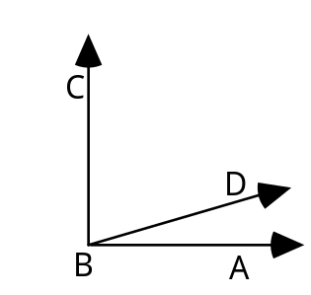
right angle, and that m(ABD)=1. What is
m(DBC)? (The drawing may not be to scale)

5. Suppose that 10 is the measure of a straight angle, that m(ABC)=7 and that m(CBD)=5. If the interiors of ABC and CBD do not overlap, what is m(ABD)? If the interiors do overlap, what is m(ABD)?

6. Using ABC as a unit, find the measure of each of the other angles to the nearest unit.

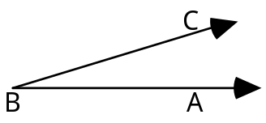
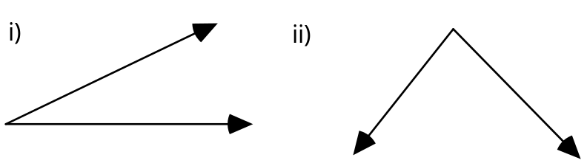

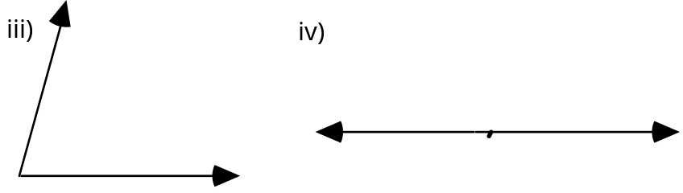

Supplement C

Geometry revisited--the deductive approach

C1: Introduction

In Supplements A and B, we discovered a number of properties of geometry which were useful in solving measurement problems (the angle sum formula and Pythagoras’ Theorem, for example.) We used several other properties without even mentioning them because they appeared completely obvious (for example the fact that two congruent right triangles can be put together to form a rectangle). These are just a few of a long list on geometric facts that have been discovered and recorded through the centuries. By the time of Euclid (about 300 BC) the list had grown so long that an attempt to organize it was in order, a task Euclid attacked with extraordinary success.

His approach, which with minor variations is still taught in many high schools today, is very similar to the approach scientists use to put their observations of physical phenomena into some cohesive logical structure. For scientists, this involves first identifying among the various “properties of nature” they have observed through the years, the ones that appear to be most fundamental and at the same time most “self-evident”. (It is important to note that these observed “laws” have on occasion turned out not to be correct at all --new and more accurate experimental techniques at subatomic scales have shown for example that Newtonian laws of mechanics are not really correct in all cases). The scientists then attempt to predict on the basis of these laws (without referring to experiments or new observation) how various phenomena should behave. These predictions can then be tested experimentally to see if the behavior really occurs. If not, an attempt is made to reformulate the basic laws in such a way as to make more accurate predictions possible. At this stage the circle of development continues--a never ending process of observe, record, identify basic principles, predict, observe (to test the predictions), etc.

In this Supplement we follow a part of the historical path of the development of deductive geometry, particularly as it appears in the writings of the Greeks, with Euclid the major contributor. We proceed in the order sketched above in the description of the scientific method. Already we have performed much of the necessary experimentation and recording of apparent “facts”, so we begin by selecting from the many facts we “know”, a few that appear particularly important and “obvious”. A scientist might call these the “laws of geometry”, but we will follow Euclid and call them axioms or postulates. From these basic assumptions we will attempt to logically deduce (mathematicians call this process proof) new facts about geometry which can be checked against our experimental observations to see if they agree. In many cases, this process will simply reinforce our belief that properties we have discovered experimentally really are valid. In some cases, conclusions based only on abstract reasoning may suggest new, as yet unobserved phenomena that experiments can validate.

C2: Points, lines and planes

Our study begins with a decision as to what particular aspects of our universe we will include in the domain of geometry? In our earlier discussions we have identified many objects of interest--segments, triangles, quadrilaterals, circles, angles-- and we could have identified many more. Each of these is an object in (3-dimensional) space. We think of space as a collection (or set) of points, each representing a single position. Euclid characterized points as having no dimensions--no length, no width, no height--a description that fits our conception of “point” quite well. A (straight) line is a set of points we picture as having infinite length (in two opposite directions), but no measurable width or height, while a plane is visualized as having infinite length and width, but no measurable height (i.e. it is viewed as a flat surface). We will consider points, lines, and planes the fundamental objects of our study.

To be formally correct, we should mention that we haven’t really defined point, line or plane since the words length, height and width have not been defined. We have just suggested informally the characteristics we visualize them as having. Advanced geometry books introduce point, line and plane as undefined objects, a position that is logically correct, but which goes beyond the understanding we expect from an elementary (or perhaps even high school) student. In this supplement we will not attempt to give a formally correct or complete treatment of Euclidean geometry, but rather try to convey the essence of the subject without getting overly encumbered by technicalities (though they are important).

A first example of the sort of simple geometric principles (laws of geometry) we will take as fundamental is

Point-line Axiom:
If P and Q are two different points in space, then there is exactly one line which contains them both.

This first axiom, which describes the most important and obvious relationship between points and lines, is surely is supported by all of our experimental evidence and observations. Without specifically saying so, the statement nicely reflects our picture of lines as straight paths, since if curved paths were also allowed to be called lines, we could easily find many lines through both P and Q (See Fig. C2-1).

Perhaps not so obvious, but easy to visualize after a bit of experimentation, is the basic relationship between points and planes:

Point-plane axiom:
If P,Q, and R are three points which do not all lie on some line, then they are contained in exactly one plane

To make this statement a bit more understandable, you might want to look at some simple examples (for instance, suppose P, Q, and R are three corners of the blackboard, and the blackboard represents the plane containing them). Then think about why the conclusion would not be true if all three points were on the same line.

The relationship between points, lines and planes is governed by

Line-Plane Axiom:
If P and Q are two points in a plane, then the line lies entirely within the plane.

In combination with our view of lines as straight, this axiom reflects the flatness of a plane, since if it were curved, the line would also have to curve to fit into the plane.

As we identify the important relationships we find between the fundamental objects of geometry, we should remember that we often refer to one point lying between two others. This is a relationship between three distinct points, which makes sense only for points lying on the same line. It is pictured in Fig. C2-2. A is between P and Q, while B is not. Since the concept “between” cannot be described in terms of our few fundamental
objects (points, lines, and planes) only, it enters our vocabulary as a new fundamental idea.

Exercises:

1. Assuming that Axiom 1 is true, explain why the following statement must be also true: If L and M are distinct lines, then L and M have at most one point in common.

C3: New objects from old

From the fundamental objects of geometry (points, lines and planes), we need to be able to build all of the objects we consider part of the subject of geometry. Probably the most important new object we want to have in our vocabulary is a segment. This we describe as follows:
The segment is the set of all points on the line which are between P and Q, together with the (end)points P and Q.

Notice that we have followed the rules of the deductive geometry game here. We have mentioned in the definition of segment only concepts already introduced--point, line, and between.

Of course, once the concept of segment is available to us, we can describe the concept of triangle:

If A,B, and C are points which do not all lie on the same line, then the triangle ΔABC is the union of the segments , and .

The points A, B, and C are called the vertices of the triangle. Again, as required by the rules of the game, this definition depends only on concepts previously introduced (we assume that the vocabulary of set theory--union, intersection, subset, etc.--is available to us in advance of our study of geometry). We could now proceed to give definitions of quadrilateral, pentagon, hexagon, polygon, using only the terms at hand. We leave these as exercises, noting that they are more difficult that the definition of a triangle since one must worry about “sides” that cross each other. A more subtle problem that occurs in defining these figures is caused by the fact that if we try to begin as with a triangle, namely picking four points X,Y,Z, and W for vertices of a quadrilateral, we have no assurance that they will lie in a plane, even though our idea of a quadrilateral is a figure lying completely in some plane (Axiom 2 gets us out of this possible predicament in the case of triangles). For more complicated figures one must stipulate as part of the definition that the vertices lie in a plane.

The name “triangle” for the three sided figure defined above is rather interesting. It suggests that perhaps we are looking at the figure differently than the person who settled on this name. The way we defined it, one would expect the name to be “trilateral” or “trigon”, indicating a figure with three sides. Of course, if we look at a picture of a triangle, and think about it as a composite of parts, we see that it could also be seen as built of angles (or at least parts of angles). To fit this discussion into our deductive geometry scheme, we need to define the term “angle” before we can legitimately use it. We know from our descriptive work in Supplement A what we mean by the term, so we need only see whether we can fit it into our scheme without introducing any new fundamental terms. We first need to define ray:

The ray (with endpoint P) is the union of the set with the set of points X on such that Q is between P and X

There’s no need for any new terms in this definition, so it is admissible. You might want to draw a picture of the set of points described here and see if it looks like you think a ray should look. On your picture you will see a second ray which is part of the line , called the opposite ray of . It can be described as the point P together with all points of which are not contained in . Now that we have defined rays, angles are simple:

An angle is the union of two rays with a common endpoint.

Notice that this definition does not use fundamental terms, but it does use only terms that have already been defined using fundamental terms. What we are trying to do is make a geometry dictionary which begins with the fundamental terms and contains no circular definitions. That is, we don’t want to define concept X in terms of concept Y and then turn around and define concept Y in terms of concept X.

A square would seem to be a logical next choice for definition. Here we run into some difficulties, despite the fact that a square seen holistically is a simple and easily identifiable object. The problem is that what we see when we look at a square, is that the sides all appear to be identical segments, differing only by their position in space. We have nothing in our “dictionary” so far that could be used to describe this phenomenon, so we must add another fundamental term, congruence (of segments and of angles), describing a relationship between these figures. Intuitively, we think of congruent figures as figures of the same size and shape, but conceivably positioned differently in space.

Euclid, and many geometers after him, used the word equal for this relationship. In modern-day mathematics this usage creates problems, since in the terminology of sets, two segments should be considered to be equal only if they consist of exactly the same points. This is more than we mean to say, so we need a new word to describe the relationship we want, hence congruent. There is a standard shorthand notation we will use for the statement “is congruent to”. We will write ≅ to mean that the segment is congruent to the segment , and similarly A ≅ B.

We could now try to define a square as a quadrilateral having all four sides congruent. Try to draw a few quadrilaterals with four congruent sides. Are they all squares? Hopefully not, or you haven’t been creative enough. A quadrilateral with all four sides congruent is called a rhombus. So a square is a rhombus, but a very special kind of rhombus--a rhombus with all four angles congruent!

A square is a quadrilateral with all four sides congruent and all four angles congruent.

We are now pretty well supplied with fundamental concepts of our geometry, let’s recap them: point, line, plane, between, congruence. Hopefully, every geometric object we will be interested in can be defined starting only with these and with the vocabulary of sets. Let’s try another--parallelogram. We decided in our descriptive phase that this should be a quadrilateral with opposite pairs of sides parallel. But what does parallel mean?

Lines L and M are parallel if they have no point in common (in set terms L « M={ }).

With this agreement, we have a usable definition of parallelogram which reflects an essential idea behind parallelism. (You might prefer a definition saying something about lines which are everywhere equidistant, a reasonable reflection of our experimental observations. We have chosen the other definition in part because we do not yet have a way to define “equidistant”.)

Finally, we should look at the concept of a circle. This is difficult, since a picture of a circle does not suggest any definitive characteristics (“round” is not part of our dictionary, so it cannot be used in a definition). If we think about making a circle with a compass, however, a good definition is suggested:

A circle with center O and radius is the set of all points X in a plane containing O for which ≅.

In the compass construction, the center of the circle is the point where the compass point is set, the radius is the segment between the compass point and the point of the pencil. The difficulty with this definition, from the point of a young child, is that a circle in nature is just a round object. It no center marked, and without a center, it is hard to visualize a radius. Notice that we have chosen here to define a circle in terms of congruence, rather that using the more common statement that a circle is the set of all points in a plane equidistant from a given point O. Again we have done so because “equidistant” is not yet in our dictionary, and we wish to keep the list of fundamental terms as short as possible.

Exercises:

1. Give a careful definition of a quadrilateral, taking care that it exclude a figure like
Do the same for a pentagon.

2. A supplement of an angle A is the angle formed by one side of A and the ray opposite to the other side.

a) Sketch an angle and its supplement. How many supplements does an angle have?

b) Give a careful definition of a right angle based on the relationship between the angle and its supplement.

3. This diagram illustrates a strange fact about segments--there is a
one-to-one correspondence between the points on the shorter segment and the longer segment ! To each point P of one associates a point P' of as follows: P' is the point of intersection of the ray and the segment .

Explain how to make similar one-to-one correspondence between the points of the small circle and those of the large circle in (a). Do the same for the points of the semicircle and the points of the entire line in (b).

C4: More “Laws of Geometry”

Once we have our basic definitions in place, we can get down to the real business of deductive geometry--identifying a few basic principles from which we hope to deduce all of the facts that we have earlier discovered via hands-on exploration. We have noted three of these (Axioms 1, 2 and 3 of §C2) which deal with relationships between points, lines, and planes. (There are several other, very technical axioms which one would need to include if this were an exhaustive course in deductive geometry. Many of these were introduced by the German mathematician David Hilbert in the late 19th century, when he undertook to bring the axiomatic setting developed by Euclid up to the logical standards required of a mathematical theory in modern times. We will pass over these, and concentrate on principles which stand out as important and self-evident to an interested person who is not trained in sophisticated mathematics.) Given the long list of known geometrical facts, one could make the choice of basic principles from this list in many ways. We will choose principles which make it easy to deduce some of the basic measurement principles--the angle sum in a triangle, Pythagoras’ theorem, and the AAA-principle for similar triangles--in a relatively short and painless manner. Our axiom set is thus rather different from that found in Euclid.

We have mentioned before that the principles chosen as fundamental should be “self-evident”, and they should be useful. Beyond the three axioms relating points, lines and planes stated in §C2, we take as a new principle

The Vertical Angle Axiom:
If two lines intersect at a point P, then each pair of vertical angles formed at P consists of congruent angles

Here vertical angles are any pair of angles such that the sides of one are the opposite rays of the sides of the other. Fig. C4-1 displays vertical
angles a and b. Notice that there is another pair of vertical angles in that diagram. Axiom 4 clearly satisfies our requirement of being self-evident. If we rotate the diagram 180∞ about the point of intersection of the two lines, it appears obvious that a will come to rest precisely atop b, and conversely, so the angles satisfy our intuitive meaning of congruent. The usefulness of this axiom will not be apparent until we discuss the exterior angle theorem.

More generally useful, but not as “self-evident”, is an axiom related to congruence of triangles. Its usefulness is tied to the fact that triangles play a very critical role as building blocks for regions in the plane. We saw in our discussion of area formulas and angle measure that rectangles, parallelograms, and even pentagons and hexagons, can be broken down into triangular regions, and properties of the triangles can be used to derive similar properties for these regions. Since Axiom 5 will refer to congruence of triangles, we need to first define this concept in terms of words already in our vocabulary, if possible. We want to be able to describe formally what t means to say informally that when one triangle is placed upon another it
will fit precisely. Let’s try to describe it for the triangles ΔABD and ΔXYZ pictured in Fig. C4-2. In this case, the obvious requirement is that after moving ΔABC and setting it on ΔXYZ, the vertices A, B, and C fall exactly on the vertices of ΔXYZ. Of course, A may not fall on X, or B on Y when they fit, but they will match up in some order. Mathematically speaking, this gives a one-to-one correspondence between the vertex set {A,B,C} and the vertex set {X,Y,Z} (there are several such correspondences but in Fig. C4-2 only A×Y, B×X, C×Z makes the triangles fit exactly). What else do we see when we fit the triangles together? is lying precisely on top of , on top of , and on top of . That is to say, the pairs of corresponding sides (for the given correspondence) of the two triangles are congruent. In the same way we see that the pairs of corresponding angles A and Y, B and X, C and Z are congruent. On the other hand, if we could have matched up the vertices so that all these corresponding parts were congruent, it is clear (at least after a bit of experimentation) that the triangle ΔABC can be fit precisely on ΔXYZ. Summarizing these observations, we define:

ΔABC is congruent to ΔXYZ (ΔABC ≅ ΔXYZ for short) if and only if there is a one-to-one correspondence between the sets of vertices of the two triangles such that the pairs of corresponding sides are congruent and the pairs of corresponding angles are congruent.

The one-to-one correspondence between vertex sets for which each pair of corresponding parts is congruent is called a congruence between the two triangles.

Warning: It is customary in many geometry texts to write ΔABC ≅ QXYZ to mean not only that the triangles are congruent, but that the congruence is A×X, BQY, CQZ . We will not use that convention here,since we wish to emphasize importance of identifying the one-to-one correspondence each time there is question of whether two triangles are congruent.

So far, we have only showed that we can increase our dictionary of geometric terminology to include a definition of congruence of triangles, using only terms already in our dictionary (as long as we include our fundamental terms in the dictionary). An important observation here is that if two triangles are congruent, then six pairs of triangle parts, three pairs of sides and three pairs of angles, are congruent. The reason that this is important, is that our experiments in Lab 16 for instance, have suggested that only knowing three pairs are congruent is enough to force congruence:

Side-Angle-Side Congruence Axiom:
ΔABC is congruent to QXYZ if there is a one-to-one correspondence between the sets of vertices of the two triangles such that two pairs of corresponding sides are congruent and the pair of angles formed by these sides (included angles) are congruent.
This axiom, which we denote by SAS, is one of the fundamental principles for Euclidean geometry. It becomes “self-evident” if we work through numerous exercises such as those in Lab 16. To gauge its usefulness, let’s look at how this might be applied to a problem. Suppose we are to measure the distance between two trees on opposite sides of Mirror Lake, and we are not allowed to enter the water (See Fig. C4-3). We could move away from the lake until we reached a point S where we could see both trees with no water
between us and the trees (of course, if the shore is irregular enough this might be impossible, but let’s assume this works). Notice that we need to know the length of one side of a triangle to solve our problem. Now we run strings from the position (S) to each tree and mark off the distance to the tree on the string. We also copy the angle between the two strings on a large sheet of paper so we can duplicate it. We move off to some level piece of land, and there use our string and angle to reproduce a triangle ΔXYZ with two sides and an included angle congruent to those formed at the lake. Since SAS says that this triangle must be congruent to the original, the side must be congruent to the segment between the trees. So, if we measure the length of this side, which we can do directly since no water now interferes, we have in fact found the distance across the lake.

Of course, this is a fairly simplistic application of SAS to an indirect measurement problem. The applications of SAS in the development of geometry are much more far reaching. An important example is pictured in Fig. C4-4. In that diagram, ACE is called an exterior angle of ΔABC.
The Exterior Angle Theorem (which seems intuitively clear from the picture) says:

An exterior angle is greater than either of the remote interior angles (ABC or BAC).

That this is called a theorem, rather than an axiom or a postulate, is no accident. The word “theorem” reflects the fact that one need not decide the truth or falsehood of the statement on the basis of experiments or observations, but that its truth can be deduced logically as a consequence of the axioms (provided that the axioms themselves are true). To verify this theorem, one need not look at any empirical evidence, one need only apply deductive reasoning to principles already accepted. Let’s work through that reasoning.

To show that BAC is smaller than ACE it is enough to show that an angle congruent to BAC lies entirely within the interior of ACE. To do this, we draw some extra points and segments in the diagram, helping us envision what is happening. We label by F the midpoint of , that is ≅. On the ray we label by G the point such that F is the midpoint of . The theorem will be proved to be true if we can show that BAF (=BAF) is congruent to FCG. How can we do this? We consider the correspondence B×G, A×C, F×F between vertex sets of ΔBAF and ΔFCG. The vertical angle axiom tells us that the corresponding angles QBFA and QGFC are congruent, and our selection of F as midpoint tells us that both ≅ and Q. Since the hypotheses of SAS are fulfilled, we can apply it to conclude that the given correspondence is a congruence between ΔBAF and ΔFCG. Once we know this, the definition of congruent triangles tells us that the corresponding angles BAF and FCG are congruent, which is what we set out to show.

The above argument demonstrates how one can discover new facts about geometry, not only by physical experimentation but by pure logical experimentation, once one has identified the fundamental principles of the system. Of course, it would now be a good test of the axioms we have selected to experiment with a number of triangles and see whether the theorem really does hold experimentally.

Another result we can deduce from SAS and reasoning is:

The Angle-Side-Angle Theorem (ASA):
DABC is congruent to DXYZ if and only if there is a one-to-one correspondence between the sets of vertices of the two triangles such that two pairs of corresponding angles are congruent and the pair of sides shared by these angles (the included sides) are congruent.

We include this theorem not only because it will prove useful a bit later (and of course is something that experimentation similar to Lab 16 would lead us to suspect was true), but because the reasoning that we use in verifying it is rather different than the “standard” reasoning we are often used to.

In applying the most common reasoning process, direct reasoning, one begins with one or more statements which are presumed to be true, and by a sequence of arguments of the sort “if this statement is true, then that statement must be true” concludes that some additional statement is also true. The proof of the exterior angle theorem followed this reasoning pattern. It began with the assumption that the vertical angle axiom was true, that the SAS axiom was true, and that it was true that certain segments were congruent. The truth of the vertical angle theorem led to the truth of the congruence of a pair of angles; the truth of the congruence of these angles and the two pairs of sides, together with the truth of SAS, led to the truth of the congruence of the triangles; the truth of the congruence of the triangles led to the truth of the congruence of the targeted pair of angles.

In some situations, this type of reasoning does not fit the information one has access to, so alternative (but equally valid) types of reasoning--indirect reasoning-- must be used instead. One common form of indirect reasoning is called reasoning by cases. Roughly speaking this works as follows. We want to prove that Statement A is true, but we do not know how to do this by a direct proof. However, we are convinced that either Statement A, Statement B or Statement C is true (3 cases). If we can prove that both Statement B and Statement C are false, we are left with the conclusion that Statement A must be true. This type argument can be applied to any number of cases.

Let’s apply this technique to the ASA theorem (see Fig. C4-5).
Suppose that the hypotheses of the ASA theorem, namely A≅X,
B≅ Y and ≅, are satisfied. We want to look at the cases possible in comparing to . One of a) ≅
b) is longer than
c) is shorter than
is surely true.

We want to show case a) is true, since then the hypotheses of SAS are satisfied so ΔABC≅ΔXYZ, which is what we are trying to show.

We will do this by showing that neither b) nor c) can possible be true. To show that c) cannot be true, we again use a proof by cases, noting that there are two possible cases: c) is true or c) is not true. We’ll show that if c) were true, then B would not be congruent to Y, which is absurd since we started out with the information that B≅ Y. We have to conclude that this case is impossible, so the remaining case-- c) is not true-- must be valid. A similar argument would show that b) is also not true.

Now let’s convince ourselves that if c) is true, then B is not be congruent to Y. If c) is true then is longer than , so there is a point D on with ≅. If this is true, then SAS tells us that ΔABD≅ΔXYZ, and then the definition of congruence tells us that the corresponding angles DBA and Y are congruent. Since DBA is larger than B, B and Y are not congruent.

After all this work, the proof of ASA is complete. It is most certainly a complicated proof, but a clever one.

Remember the problem of measuring the distance across the river in §B3.
To make it work, we needed to know that a triangle with two congruent angles, has congruent sides opposite those angles. If we look at a few pictures, we can easily believe that this statement is true. Without looking at pictures, we could also convince ourselves that it is true, basing our deduction only on the “self-evident” axioms we have written down, and the theorems we have proved using those axioms. Let’s consider the situation pictured in Fig. C4-6, and suppose that we know that A≅B. Now consider ΔABC, and the correspondence A×B, B×A, C×C of its vertex set with itself. We know that A≅B, B≅A and ≅ (in fact they are equal), so by ASA this correspondence is actually a congruence of ΔABC with itself. So the corresponding sides and must be congruent, which is what we set out do show.

Exercises:

1. Using the SAS axiom as a starting point, give a convincing argument that a triangle with two congruent sides (an isosceles triangle) has congruent angles opposite those sides.

2. Suppose that the correspondence A×X, B×Y, C×Z is a congruence between ΔABC and QXYZ, and that ≅ . What other correspondences between the vertex sets must also be congruences? Which correspondences would be congruences if the triangles were equilateral, that is, all three sides of ΔABC were congruent?

3. I×S, J×T, K×R is a correspondence (but not necessarily a congruence) between the vertex sets of triangles ΔIJK and ΔRST. List the pairs of corresponding sides (for example × ). List the pairs of corresponding angles.

4. The triangles below are not accurately drawn, but you are to assume that they are accurately labeled. Which of the pairs of triangles are congruent? For each pair, explain how you know they are or are not congruent, or note that not enough information is given to come to a conclusion. For each congruent pair, give the relevant correspondence between vertex sets.

5. Find x and y.

C5: Parallel lines

One of the enduring mysteries in geometry, from the time of Euclid until the 19th century, was concerned with the role of the concept of parallel in the setting deductive geometry. Already by the time of Euclid, it was known that if we accept his axioms as true, then we must logically accept the fact that there are parallel lines. One can deduce this from the following theorem (see Fig. C5-1).

Alternate Interior Angle Theorem (part 1):
If L and M are distinct lines in a plane, with transversal T, and if a pair of alternate interior angles formed are congruent, then L and M are parallel.

Before trying to deduce this from our axioms and previous theorems, we should make sure the terminology is clear. By a transversal to two lines L and M, we mean a line which intersects them both.
By alternate interior angles formed by a transversal, we mean angles such as α and β in Fig. C5-1. It is, of course, possible to give a formal definition of these angles in terms of L, M, T and their points of intersection. We leave that as an exercise. There are two pairs of alternate interior angles in Fig. C5-1, only one of which has been labeled.
Note also that there are transversals (and accordingly pairs of alternate
interior angles) for any pair of distinct lines in a plane (see figure C5-2), not just for parallel lines. The distinct feature of parallel lines is that the pairs of alternate interior angles are congruent.

We will use indirect reasoning again in deducing that the theorem stated above is true. So we begin with the fact that the angles a and b are congruent, and reason by cases: a) L and M are parallel, or b) L and M are not parallel. We want to rule out case b) by showing that it leads to an absurd conclusion. So suppose that the lines L and M are not parallel, that is, they meet at some point P. Let’s suppose that P is on the right side of T in Fig. C5-1, so b is an exterior angle of the triangle ΔABP, and a is a remote interior angle of that triangle. (Sketch this picture to better understand the proof). Now we know from the exterior angle theorem that b is greater than a. But this is absurd, since
we started out knowing that they were congruent. Reasoning by cases, we conclude that b) is false, so a) must be true. So the lines must be parallel.

This alternate interior angle theorem gives us a way to construct parallel lines provided we know how to copy an angle (See Fig. C5-3). If we begin with a line L and a point P not on L, we draw any line T through P which intersects L. At P we copy the angle a formed by T and L as in Fig. C5-3, , with one side a ray lying on T. By our alternate interior angle theorem the remaining side of this angle lies on a line M through P parallel to L. This argument gives us the

Existence of Parallels Theorem:
Given any line L and any point P not on L, there is a line M through P which is parallel to L.

The alternate interior angle theorem also provides a practical test for parallelism: To determine whether lines L and M are parallel, draw a transversal and compare the alternate interior angles formed. They are congruent if, and only if, the lines are parallel. This is particularly useful because the definition of parallel, given the fact that lines extend indefinitely, is one that could never be checked directly. (How far along the lines would you have to go before you concluded that they would never meet?).

The real controversy related to parallel lines which followed the publication of Euclid’s Elements dealt with the converse of the theorem we have stated above. Euclid took as an axiom a version of the following:

The Parallel Axiom:
Given a point P not on a line L, there is exactly one line through P parallel to L.

That is, once we use our theorem to find a parallel through P, there are no other parallels possible. As axioms should, this one seems self-evident, and in fact no one doubted that it should be true. The question was--should this really be called an axiom, or should we be able to prove it as a theorem on the basis of the other axioms we have already selected. Many people attempted to prove this through the centuries, until 19th century mathematicians succeeded in showing that it could not be proved from the other axioms--Euclid had guessed right. We will take the Parallel Axiom as our final fundamental principle of geometry (it joins the Point-Line Axiom, the Point-Plane Axiom, the Line-Plane Axiom, the Vertical Angle Axiom, and SAS). As a first consequence of this axiom, we can deduce that the converse of the alternate interior angle theorem (part 1) is true.

Alternate interior angle theorem (part 2):
If two parallel lines L and M are cut by a transversal T, then the alternate interior angles formed are congruent.

Before we look at the reasoning behind this claim, you should make sure that you understand that this says something different than part 1 of the theorem. The words are nearly the same, and this leads many first time readers to assume that these are the same statement. Look carefully at the two statements, and compare the statements to the following two: i) When it rains, the Clippers don’t plan: ii) When the Clippers don’t play, it rains. The Part 1 and Part 2 of the Alternate Interior Angle Theorem have exactly the same relationship as these two statements about the Clippers. They are converses of each other, and the truth of one does not automatically imply the truth of the other.

So how do we “prove” part 2? Let’s suppose that L, M, and T are the lines pictured in Fig. C5-1, and that A is the point where L and T intersect. Now forgetting L, we construct as in the proof of the Existence of Parallels Theorem, an angle at A congruent to the angle –b formed by M and T. One side of this angle lies on a line L’ which is parallel to M and which forms congruent alternate interior angles by the manner in which it was formed. Now we have both L and L’ being lines parallel to M and passing through the point A. The Parallel Axiom tells us that these are the same line, so L=L’. We conclude that since L’ gives us congruent alternate interior angles, so must L, which is what we set out to show.

Let’s recall that one of the rules of the deductive geometry game is that one periodically checks the predictions of the theory against observations from experiments. We can do that now, returning to an old question about the angles of a triangle (see Fig. C5-4). We begin with a triangle ΔABC, and take a line L through C parallel to (which exists because of the
Existence of Parallels Theorem). α and σ are alternate interior angles (for transversal ), so they are congruent by Theorem 2. For the same reason, β is congruent to ε (use transversal ). Looking now at the angles formed at the point C, we see that our deductive geometry predicts that congruent copies of the three angles of the triangle, laid side by side, form exactly a straight angle--something we observed experimentally by cutting out triangles and tearing off their angles.

During a recent workshop, teachers who were asked to determine a method to measure the distance across Mirror Lake (see §C4),
generally chose the method pictured in Fig. C5-5. They attempted to move from the two trees along parallel paths, and thus to form a parallelogram with side . They then measured this side and asserted that they had found the distance between the trees! Why would this work? The required fact, which seems to be true if we experiment with various parallelograms, is: opposite sides of a parallelogram are congruent.
This is again something we can attempt to deduce directly in our geometry, without experimentation (see Fig. C5-6). Here ABCD is a parallelogram, so is parallel to and is
a transversal to the lines containing these two segments. The alternative interior angle theorem tells us that ADB≅DBC. Now using the parallel sides and , with transversal we see that the alternate interior angles ABD and CDB are congruent. Combining these facts with the fact that is congruent to , we can use ASA to conclude that A×C, B×D, D×B gives a congruence between ΔABD and ΔBCD. Since corresponding sides of congruent triangles are congruent, we see that ≅ and ≅. Which is what we set out to show. In fact, we actually showed more, since if we look at corresponding angles we will discover also that opposite angles of a parallelogram are congruent.

Exercises:

1. Is it possible to find a pair of lines which are not parallel, yet which do not have any points in common? Explain.

2. Explain carefully why the measure of each angle of an equilateral triangle must measure 60∞.

3. Which of the following pairs of lines do you know are parallel (assuming all angle measures are in degrees?

4. Assuming that the labeling (in degrees) is correct, are there any parallel lines in the diagram below? Any right angles?

4. The diagram below is not drawn to scale. Assume that L is parallel to M and that m(a)=75∞, m(b)=138∞ and m(c)=35∞.

Find the measures of the other marked angles.

5. Suppose that DABC is isosceles.
a) What are the measures of the other angles if m(a)=92∞?
b) What are the measures of the other angles if m(a)=38∞?

7. Suppose that is a diameter of a circle with center P, and that K is a point on the circumference of the circle.

a) Explain why PAK ≅ PKA

b) Explain why PBK ≅ PKB

c) Explain why 2m(PKA)+2m(PKB)=180∞

d) Conclude that BKA is a right angle (this result is often stated as: an angle inscribed in a semicircle is always a right angle)

8. Look back at the proof of the Exterior Angle Theorem in section C4. There we showed that ACG ≅ A. Explain why it then follows that GCE ≅ B. Then explain why m(A)+m(B)=m(ACE) (in other words the measure of an exterior angle of a triangle is equal to the sum of the measures of the remote interior angles).

9. Find the area of this isosceles triangle. (Hint: you may want to sketch in a segment from the top vertex to the midpoint of the base). Explain carefully why your technique for computing the area works.
10. In ΔABC m(A)=70∞. In ΔXYZ m(Y)=115Q. Is it possible that the triangles are congruent?

11. Suppose you are standing on the side of a deep stream, and a tree stands on the other side. If you sight from point A (on your side of the stream) to the top of the tree, the line of sight makes an angle of 30∞ with the (level) ground. If you walk directly away from the tree 15 feet from point A, the line of sight makes angle of 15∞ with the ground. Describe how you could use this data to determine the height of the tree. What is it?

12. In the diagram below, the pair of angles a and b are called corresponding angles formed by the transversal T to the lines L and M.
Using the Vertical Angle Axiom and the Alternate Interior Angle Theorem, explain why L is parallel to M if and only if a and b are congruent.

C6: Similar triangles and more indirect measurement

One of the most useful measurement tools based on geometry is the theory of similar triangles. Intuitively, similar triangles are of the same shape but not necessarily of the same size. In particular, congruent triangles are always similar, but similar triangles aren’t always congruent. Perhaps the simplest example of the latter are two equilateral triangles, one with sides of length 2, one with sides of length 3. If we try to describe similar triangles in terms of relationships among their parts, as we have done with congruent triangles, it is clear that we cannot specify congruence of pairs of sides, but examination of a number of pairs of triangles for which there is a one-to-one correspondence between vertex sets such that all pairs of corresponding angles are congruent shows that this condition, which we will call the Angle-Angle-Angle Similarity Criterion (AAA for short), produces triangles which we would agree of the same shape. It is natural to
ask what, if any, relationship there is between lengths of sides. We hope, of course, that some useful relationship will exist, since that could be the basis of useful applications of similar triangles.

Lets look at a simple example. Suppose that for triangles ΔABC and ΔXYZ as pictured in Fig. C6-1, a) we know that A≅X, B≅Y, and C≅Z (that is, the AAA similarity criterion holds) and suppose also that we know that XZ=2AC, that is, we know that one side of ΔXYZ is twice as long as the corresponding side of ΔABC. In Fig. C6-1 b), we have copied ΔXYZ and labeled the midpoint of by W, so we have ≅≅. Now we draw a line parallel to through W and label the point where it meets by U; and we draw a second line through W, this time parallel to and meeting at the point V. Now we can apply practically everything we know about parallel lines and congruence of segments.

First, we have that ≅ since UYVW is a parallelogram. Then we look at the two triangles ΔXUW and ΔWVZ with correspondence X×W, U×V, W×Z. We know WXU≅ZWV. Why? Similarly we know that XWU≅WZV. Why? Since we started with the fact that ≅, we have exactly the right facts to apply ASA to see that our correspondence is a congruence. Since other corresponding parts must also be congruent, we get that ≅. Combined with ≅, which we already knew, we have ≅, which means that U is the midpoint of and XY=2XU.

Now we started the problem knowing that A≅X, B≅Y, and C≅Z, and we just saw that XWU≅WZV= Z. So we know that C≅XWU and A≅X, Plus we have that AC=XW so ≅. This is enough to show (using ASA again) that A×X, C×W, B×U is a congruence between ΔABC and QXWU, and in turn that ≅ so AB=XU. What we really showed here is that our process succeeded in copying ΔABC inside ΔXWU with A landing on X.

All together, we have seen that XY=2AB, that is, side is twice as long as side . If we had made a similar argument, copying ΔABC inside ΔXWU with C landing on Z we would have showed that YZ=2BC.

This formally rather complicated (but visually fairly simple) argument verifies one special case of the important

AAA Similarity Theorem:
If there is a one-to-one correspondence between the sets of vertices of two triangles such that all three pairs of corresponding angles are congruent, then the ratios of the lengths of the pairs of corresponding sides are equal.

In this particular case we showed that if one ration is 2:1, then all three ratios are 2:1. In Fig. C6-2 we sketch a diagram that could be used to show the same result if the ratio of XZ to AC were 3:2, rather that 2:1. You should be able to show that the three small triangles are all congruent, and thus
conclude that the three parallel lines , and the line bisecting divide the side into three congruent parts, two of which make up , so the ratio of XY to AB is again 3:2 as the theorem asserts. It should be clear that for any whole numbers m and n, this same picture would generalize to show that if XZ to AC were m:n, then the ratios of the other pairs of corresponding sides would also be m:n. Note that these pictures are the same as those we encountered in studying triangular tessellations in Lab 28.

How is this useful? Suppose we were to need to find the height of a flagpole erected vertically on level ground. Fig. C6-3 shows an approach that will give the height (without climbing the pole). One person (P) sights from
ground level to the top of the pole, another rests a meter stick perpendicular to the ground in the line of sight so the sighter can read the height (d centimeters) on the stick which lines up with the top of the pole. Another team member measures the distance from P to the meter stick and from P to the base of the pole, all in centimeters. Now there are clearly two similar triangles in this picture, since both share the angle at P, both have a right angle, and the third angles in each must be congruent since the three angles of a triangle together make up a straight angle. The AAA Theorem tells us that, if h is the height of the pole, the following proportion is valid:
h:d = distance to pole:distance to meter stick.
Solving this proportion would give the height of the pole in centimeters. Of course, one could also measure everything in meters. (If only whole numbers are to be used, what would be the advantages and disadvantages of using meters rather than centimeters?) For example, if the height read on the meter stick were 80 cm, and the distances to the pole and meter stick were respectively 620 cm and 124 cm, we would have to solve the proportion h:80=620:124. This is equivalent to 124h=80∞620, which gives a solution of h=400 cm.

In many problems dealing with similar triangles, it is only feasible to show, as we did in this example, that two pairs of corresponding angles of the two triangles are congruent. The remaining angle is often positioned where it cannot be directly measured. Thanks to the Angle Sum Theorem, however, this is enough to invoke the AAA Theorem. Suppose, for example, two triangles each had an angle of measure 75∞, and each had an angle measuring 38∞. The Angle Sum Theorem then tells us that the third angle in each triangle has measure 180∞-(75∞+38∞)=67∞, so we conclude that all three pairs of corresponding angles are congruent. Using this reasoning at the outset, we could have renamed our theorem the AA Similarity Theorem, with the necessary change in hypotheses, and no change in the conclusion. This is, of course, a better form of the theorem, since we need only feed in two pieces of information (rather than three) to get the same output.

As an interesting application of the AA Similarity Theorem we can give a short proof of Pythagoras’ Theorem, without using areas as we did in our first discussion of that result. We begin with the right triangle ΔABC in Fig. C6-4, and draw in an altitude through vertex B to the opposite side. Now
ΔABC and ΔBDC satisfy the AA hypotheses, since each has a right angle (and these are certainly congruent), and the triangles share the angle C. So for the correspondence A×B, B×D, C×C the ratios of the lengths of corresponding sides are congruent. In particular BC:DC=AC:BC or (BC)2 =
=AC ∞ DC. Comparing the triangles ΔABC and ΔBDA, which share the angle A, we see similarly that A×A, B×D, C×B satisfies the hypotheses of the AA Similarity Theorem, so AB:AD=AC:AB or (AB)2= AC ∞ AD. Adding the underlined equalities, and using the distributive property we get
(AB)2+(BC)2 = (AC ∞ DC)+(AC ∞ AD)= AC ∞ (DC + AD) = AC ∞ AC = =(AC)2. That is, the square of the length of the hypotenuse is equal to the sum of the squares of the lengths of the sides!

Exercises:

1. A triangle has sides of lengths 2, 3, and 4 units. A second triangle, similar to the first, has perimeter 18. What are the lengths of the sides of the second triangle?

2. A child’s stack toy is make up of ten discs of increasing radius, which fit over a central spindle. Each disc is 3 cm thick. When viewed from the
side, the stack looks like this. Assume the “edges” lie on a line as shown. Use similar triangles to find the radius of each disc.

3. Find the lengths a, b, and c.

4. In the diagram below a) Is DABC similar to DDEC? Explain
b) Is parallel to ? Explain.

c) If m(–D) = 40∞, find the measures of all the other angles in the diagram.

.d) If CD = 3, AC = 9 and AB = 6, find
DE.

5. Two similar triangles have the lengths of corresponding sides in the ratio of 1:3. What is the ratio of their areas?

5. Is it true that any 2 equilateral triangles are similar? Explain. What about two isosceles triangles?

7. Suppose the triangles below, while not accurately drawn, are accurately labeled, with angle measures in degrees. Find x in each pair.
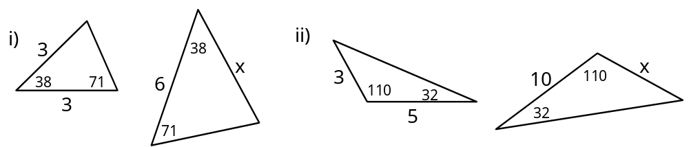

8. In ΔABC, m(A) = 62∞, m(B) = 54∞. In ΔXYZ, m(x) = 54∞,
m(Y) = 64∞. Is ΔABC similar to ΔXYZ? Explain.

9. Suppose that is a diameter of a circle, P a point on the circumference of the circle and XŒ such that 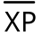 is
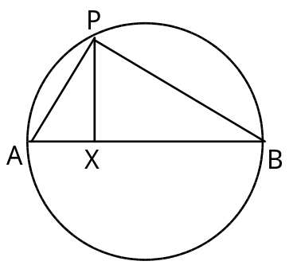
perpendicular to . Argue that the triangles ΔAXP, ΔXPB, and ΔAPB are similar.

10. A triangle with sides of lengths 3, 5, and 7 is similar to a triangle with longest side of length 21. How long are the other sides of the second triangle.

11. A man who is 6 feet tall stands 8 feet from a lamp pole which is 12 feet tall. If the light from the lamp casts a shadow on the ground, how long is the man’s shadow?

